KINGSTONE & THRUXTON GROUP PARISH COUNCIL
Minutes of a meeting held on Wednesday 1st March 2023
At 19.00 in Kingstone Village Hall

Present:
Cllr Neil Howard, Cllr Colin Knight, Cllr Denise Lloyd, Cllr Keith Price, Cllr Colin Pugh (Chairman), Cllr Lynne Thorne, Cllr Colin Warrillow and Cllr John Watkins

In attendance:
Ward Cllr Christy Bolderson, Lisa Lewis (Parish Clerk), PFO Paul Neate (Parish Footpath Officer), Steve Madison (Sports Association) and four members of the public.

Agenda Ref | Minutes
1. | Apologies for absence - None received. The resignation of Paul Richards was acknowledged.
2. | Vice-chairman Cllr Colin Warrillow was proposed and unanimously elected as vice-chairman.
3. | To receive declarations of interest & written requests for dispensation none recorded
4. | Approval of minutes and sign from parish council meeting held Wednesday 1st February 2023. It was RESOLVED to adopt the minutes as a true record, and they were signed by the chairman.
5.  5.1 | Members of the Public The following points were noted and discussed:-  - No points / questions were received.  Correspondence Received:  - Email received from a resident listing several issues/ concerns regarding lengthsman, footpaths and drainage. Email circulated to Cllrs. The email was noted and councillors confirmed that any Footpaths Issues are directed to the PFO through the clerk and in turn to Herefordshire Council. Highways issues are reported to Herefordshire Council. It is the Parish Council job to check the work being carried out by the lengthsman and they are happy with the standard of work.  - Email received from a local resident reporting anti-social behaviour in the evenings in the primary school car park. They have already reported to police but are yet to receive a response. I have requested further details and forwarded to the local policing team to make them aware. Also suggested this should be reported by the resident to the school. Email since received and the police are dealing with the concern.  - Email of thanks for the generous donation received from Dore Community Transport.  - Email received from resident of Thruxton to remind the PFO about the broken stile on TX1. And request information on the progress made with the revision of the NDP. The PFO confirmed the stile has been reported, he will follow up. It was noted that revisions cannot take place until the local plan is finalised, however Cllrs Pugh, Warrillow and Watkins will form a working group to review the road plans.  Planning – FOR INFORMATION ONLY  None to note.
6.  6.1  6.2  6.3  6.4  6.5  6.6 | Verbal Reports  Local Policing Team Reported:  - An individual, believed to be responsible for several thefts in the area, received a 28 week sentence.  - Surveys are to be gathered from all residents to receive local views.  - There has been an increased police presence around Kingstone.  - Police will attend the parish council meeting once every quarter.  Ward Cllr, Christy Bolderson reported on:  - Full Council meeting had taken place to approve budget with an increase of 4.99% agreed.  - Public Rights of Way grants  - Children’s services – Eleanor Brazil’s report had been published.  - Cabinet meeting on 2nd March to include City Masterplan, Transport Plan, Eastern River Crossing, Public Realm, Restoring the Wye and S.106 funds.  Lengthsman – not present. Reports for work carried out had been received. Grant funded drainage work is underway.  Village Hall Committee reported:  - The new kitchen has been installed.  - Currently looking to raise money to replace the windows and doors.  - Table top sales to sell unwanted china etc.  - Hall being well used by the community.  Sports Association Reported:  - Trees bordering the field are to be trimmed.  - Theft of new equipment. Security has been improved.  - Hereford Council confirmed 106 money can be utilised for replacement of Equipment and security.  PFO Reported:  - Majority of paths have now been walked and inspected.  - All stiles have been checked, most are in good repair but a few aren’t and these have been reported.  - The PFO made a request to be able to use power tools. Clerk to establish what can be done.
7. | Dirt Bike Track  - Bike Track Licence – the map has been amended in liaison with the police to alter the position of the bike track slightly to take into account drainage and man hole covers on the site. The shelter will need to be moved. The business plan has been updated with the revised map and sent to Connexus. Amended licence awaited. It was RESOLVED to delegate authority for the completion and agreement of the licence to the clerk. It was noted that the draft had been looked over by the solicitor appointed for the Allotments and have been advised it is a standard agreement. Clerk to arrange completion of the licence with Connexus.  - Lead Councillor – Colin Knight and Colin Warrillow will look into this further.
8. | Jubilee Oak Seating - No updates. Clerk to follow up.
9.  9.1  9.2  9.3  9.4  9.5  9.6 | Financial Reports  The schedule of payments for February shown in appendix 1 was APPROVED.  Banking - Bank balances and reconciliation for end of December 2022 were noted and statements signed by the chairman.  Donation request of £500 from Food For Families was considered, it was RESOLVED to decline support on the basis that it doesn’t support a large enough percentage of the parish.  Membership of HALC and the benefits were considered, however is was RESOLVED that membership is not required.  Individual parish council email addresses were considered and it was RESOLVED that these are not required.  Adoption of a donation’s policy – item deferred.
10. | Planning  230253 – Brightwells Auction Site, Stoney Street Industrial Estate, Madley Hereford HR2 9NH - Proposed erection of storage building for use in connection with established enterprise The Application was considered and it was RESOLVED to respond in support of the application with no comments to note.
11. | Drainage No updates.
12. | Allotments The Parish Council’s appointed solicitor has sent a copy of the draft land transfer with several queries. A committee meeting is required to review the document and questions raised. Cllrs Colin Pugh and John Watkins remain as committee members with Cllrs Howard and Price proposed as additional members. It was agreed Cllr Neil Howard will take over as lead councillor. Clerk to arrange a meeting.
13.  13.1  13.2  13.3  13.4  13.5  13.6  13.7 | Highways & Environment  Lengthsman - Already covered under item 6.3.  Mowing the quote from Doug Addis for £350 for mowing the triangles at Gooses Foot and the Church was considered and it was RESOLVED to accept the quote. Clerk to action. It was noted that Doug does an excellent job of maintaining the village.  Road Calming and 106 funds – It was noted that a tender pack is to be issued by Herefordshire Council. This has not been received and therefore Ward Councillor Bolderson confirmed she would follow up for the council.  SIDS – no updates. Agreed to put on hold.  Village Name Signs & Gateways – The estimate provided by BBLP for £500 for the design and site visit and survey for installation of village gates was considered which would include the ‘Drive Carefully’ sign and village name sign designs was considered and it was RESOLVED by a unanimous vote to proceed with the survey. Clerk to organise.  KS25 – Improvements were discussed and it was RESOLVED to obtain quotes for tarmacking of the path. Clerk to arrange.  Potholes – it was noted that a number of potholes have been filled through the village.
14. | Meeting Dates due to the local elections taking place it was noted that the meeting date for May will need to be moved, it was RESOLVED to hold the Annual Meeting of the Parish Council on the 17th May 2023, with the Parish Meeting held immediately before.
15. | King’s Coronation Plans  - A member of the public advised the council that plans for an afternoon tea for all residents, organised by the Church and Village Hall Committee which will be held in the village hall were underway. There was a request for a donation of £200 to fund the event to make it free for all residents. The request was considered and it was RESOLVED by a unanimous vote to support the event and donate. Should further funding be required then the council would be happy to consider further donations.
16. | Tribute to the late chairman, ideas were discussed and it was considered that the planting of a new Oak Tree to replace the one planted earlier in the year off Cooks Lane would be appropriate. Clerk to request support from Whitfield Estate and obtain costs for a plaque.
17. | Items for next agenda  - Elections  - Newsletter on May’s agenda
18. | Date of next parish council meeting is Wednesday 5th April 2023
19. | Meeting closed at 8:52pm

SIGNED………………………………………………………… DATED…………………………….

Appendix 1
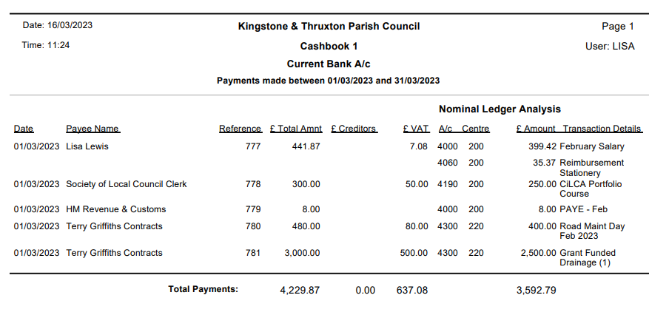
Appendix 2
